Access and Benefit-Sharing Policy Development
Report: SITUATIONAL AND STAKEHOLDER ANALYSIS
Maureen Hilyard, January-February 2018

INTRODUCTION
At the start of the week of 15 January, Heads of Ministries (HOMs) related to ABS were notified by email about the consultation process for the ABS Policy Development project and asked to consider a date for a short discussion about their section’s plans to incorporate ABS principles of the Nagoya Protocol into their respective policies and, if necessary, legislation. In most instances, a follow-up phone call and email were required although some have still to get back to me with a specific time for our interview session.
SUMMARY OF FINDINGS
This report basically studies the access to different government resources, in general for some type of research and to whom the benefits are assigned. The Research Unit of the Office of the Prime Minister is the initial landing stage for any research enquiry and application. The whole application process is overseen by the Cook Islands Research Committee which will assign the specific access route for research applications depending on the type of research that will be undertaken in the Cook Islands – for academic, medical, commercial purposes. The Traditional Knowledge Act recognises the Are Korero as being the acknowledged keepers of traditional knowledge, so that it is probably more appropriate that they are represented on the National Research Committee to discuss any issues relating to the traditional knowledge which may be used in association with the genetic resources of a plant that is of interest to the researchers. According to the Ministry of Culture however, the House of Ariki should be the first ones consulted about anything cultural, including traditional knowledge. There were differing opinions in the Pa Enua about this.
Each Ministry department has its own criteria and expectations with regards to research. At the moment, an application will be presented once it has been passed through the Research Committee process, to the appropriate Ministry for their support. Where there are commercial benefits expected from any research, the application would be directed to the ABS process requiring negotiation of Mutually Agreed Terms (but at this stage it is unknown where this will occur). Where there is traditional knowledge associated with the plant then Prior Informed Consent must be given from the provider of the plant and the information about the medicinal or other benefits of that plant. Gerald McCormack believes that there are no endemic plants from the Cook Islands to which there is any traditional knowledge associated. The plants that do, are plants common throughout the Pacific, and similar uses of that plant may also being applied in other countries as well. The use of registers was quite controversial among holders of traditional knowledge. General consensus was that a register held by the Are Korero on their island would be preferable to that with the Ministry of Culture, and any requests for access had to have the consent of the Are Korero of the respective island.
The benefits derived from any potentially commercial research undertaken through the various Ministries varied, currently depending on its own legislation. For Seabed Minerals the benefits derived from any prospecting on our seabed are assigned to the government on behalf of the people. For Agriculture the benefits of their genetic research go to the global community through the ITPGFA with whom they have shared research knowledge and resources about food security since 2004. In the case of Marine Resources license fees are paid by foreign fishing companies for their vessels to fish in our exclusive economic zone, are paid to the government. A fraction of the fee is retained by Marine Resources which is then distributed to the Island Fishing Clubs or Associations through the National Fishing Association.

ABS REPORTS ON INDIVIDUAL INTERVIEWS and PA ENUA COMMUITY MEETINGS
MAUREEN HILYARD, FEB 2018

- Mat Purea & William Wigmore, Agriculture p2
- Ngarangi Tangaroa-Teio & Charlene Hoff, OPM, Research Unit p4
- Paul Lynch, Seabed Minerals p6
- Gerald McCormack, Natural Heritage p8
- Paul Allsworth, and Te Koutu Nui Executive, Te Koutu Nui p9
- Valentino Wichman, Health p10
- Anthony Turua & Repeta Puna, Cultural Development p11
- Kelvin Passfield, Te Ipukarea Society (email) nil
- Ben Ponia, Marine Resources (emails and ph messages) nil
- Community Consultations - Aitutaki (Dec 2017) p13
- Community Consultations - Mangaia (Feb 2018) p15

Ministry of Agriculture: Mat Purea, HOM; William Wigmore, Head of Research (23 Jan)
The only HOM who responded immediately to my call for a meeting relating to the ABS Policy Development Process was Mat Purea from the Ministry of Agriculture. His Head of Research, William Wigmore, was at the time attending an FAO meeting of the parties to the International Treaty on Plant Genetic Resources for Food and Agriculture (ITPGRFA), so Mat already had an idea of what I might be going to talk about and was willing to contribute his Ministry’s views. Mat and I met with William on his return to work (23 Jan). The Ministry has been an active member of the ITPGRFA organisation since 2004.
As a background to the ITPGRFA: when the Convention of Biological Diversity (CBD) was adopted in 1992 and entered into force in 1993, it recognised the importance, and some of the special problems, of Plant Genetic Resources for Food and Agriculture (PGRFA). A special commission was formed to negotiate the treaty in harmony with the CBD. It was adopted by the FAO Conference in 2001. The ITPGRFA provides a framework for international collaboration in PGRFA and whose key objectives are:
- The conservation and sustainable use of plant genetic resources for food and agriculture
- The fair and equitable sharing of benefits derived from their use, in harmony with the CBD, for sustainable agriculture and food security.
On ratifying the Treaty, countries agree to make their genetic diversity and related information about any crops stored in their gene banks available to all through the Multilateral System (MLS) of access and rules regarding benefit sharing.
Benefit sharing includes:
- Facilitated access is itself a major benefit
- Exchange of information
- Access to and transfer of technology
- Capacity building
- The sharing of monetary and other benefits of commercialisation (although part of the monetary benefits is placed into an international Benefit-Sharing Fund, which s to support conservation and crop improvement efforts, especially by small scale farmers in developing countries)
The Standard Material Transfer Agreement (SMTA) is a legal commercial contract between a provider and a recipient that sets out the terms and conditions under which plant genetic resources are transferred:
- Obligations of the provider
  - To make material under the multilateral system available expeditiously and free of charge
  - To do so under the SMTA (listing the materials provided; providing information the Treaty’s governing body about the SMTAs entered into; adopting a schedule and requirements for reporting; having a website to facilitate reporting on SMTAs
- Right of the recipient
  - Can use the material for research, breeding or training purposes
  - Can develop new PGRFA products and can protect and commercialise them
  - Cannot use materials for other purposes or for uses outside of food and agriculture
- Obligations of the recipient
  - Not to take out any patents or Intellectual Property Rights (IPRs) over the material accessed from the multilateral system that may restrict its availability to others
  - Make available to the multilateral system any non-confidential information resulting from research and development on the material
  - Make a mandatory payment to the multilateral system if the recipient: develops a new PGRFA product derived from the material; commercialises the new product; and restricts the availability of the new product to others for further research or breeding
  - If further availability is not restricted, then payments are voluntary.
The Ministry has been involved in a number of research projects over the years that have contributed to the sharing that the ITPGRFA advocates. An example is that among its 29 varieties of taro here in the Cook Islands, 5 have been identified as resistant to taro leaf blight. Tissue culture is kept by the Fiji SPC for when there is a need to reproduce food resources for countries that need a particular variety.
While the Ministry of Agriculture has participated regularly in ITPGRFA activities since 2004, its involvement in the programme and its activities is not reflected in any of its current policies, nor is there any formal recognition of any research undertaken by the Ministry recorded with the Research Committee of which Agriculture is a member. The Ministry aims to move towards rewriting their policies to incorporate its relationship with the ITPGRFA and its access and benefit sharing principles, noting how they are involved as providers of information and resources, as well as recipients of any benefits from this arrangement. They will also formally acknowledge any future research on genetic resources that is undertaken by the Ministry and record this under any new procedures that are implemented by the Research Committee.

Policy and Planning and Research Unit, Office of the Prime Minister: Ngarangi Tangaroa-Teio, Director (23 Jan); Charlene Hoff, Policy (1 Feb)
The Research Unit has only just recently reviewed its research policy. Access and Benefit Sharing is one of its three key areas. Charleen Hoff will take over the ABS research section. Once I have spoken to more Ministry heads I am arranging to have a chat with Charleen to discuss how we can possibly fit their different models into a single framework.

Prior to my discussion with Ngarangi, Louisa had e-introduced us to Daniel Robinson (Associate Professor of the Masters of Environmental Management Program Authority (Arts and Sciences Faculty) University of New South Wales, Australia). He is currently working with Andreas Drews who is the regional coordinator of the ABS Initiative (http://www.abs-initiative.info/) in the Pacific region, and together they aim to work closely with the SPREP ABS project whose Samoa workshop Emily attended in July 2017. Daniel offered support on ABS processes and legislation via correspondence, and proposes to provide some in-country support in mid-2018.
Daniel Robinson sent us a sample framework which I discussed with Ngarangi who plans to incorporate the Research Unit’s initial process into the initial part of this framework to encourage some further discussion by the teams working on this project. The current working framework is as follows:

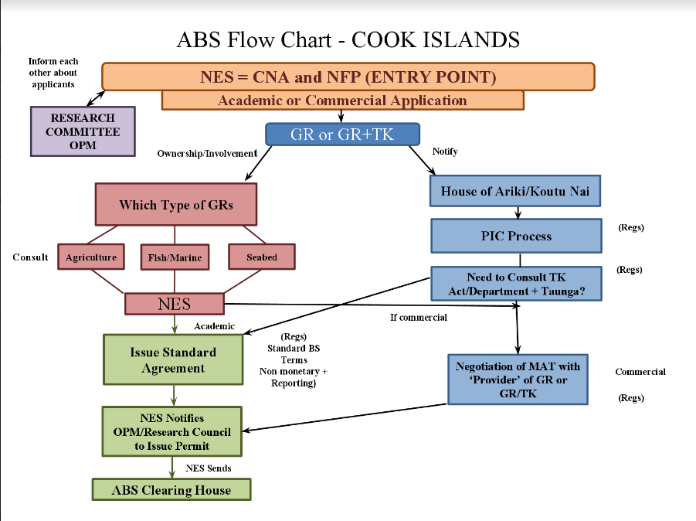
On Feb 1, because Charlene Hoff was unable to attend this first meeting, a follow-up meeting was held with her to discuss any further developments.

Some discussion points:

1. A followup on the offer that Ngarangi made during our earlier discussion of the Research Unit process based on the recent review (as a flowchart) to precede the proposed framework that Daniel Robinson from UNSW/SPREP developed. Or perhaps, as discussed, Daniel's proposal might be amended based on inputs from the Research Unit or the Research Committee and perhaps incorporating the views of other other stakeholder groups.

2. Currently the process used by the Research Unit and related decision-making bodies is as follows. 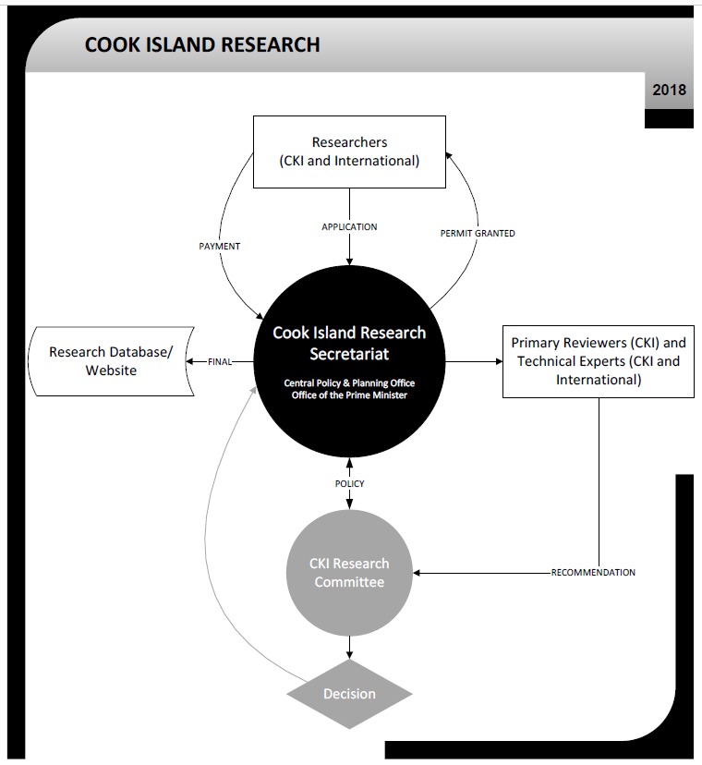

A new revised version taking into account discussions that the Research Unit is being formed in conjunction with other parties interested and involved in the application process. I also believe that an online application process has already been looked at, but is awaiting final approval.

We should encourage online enquiries and applications, especially at the preparatory stage which could initially outline the criteria and provide a checklist of the prerequisites to be met BEFORE an application for research in the Cook Islands can proceed to a more formal level.

Discussions with Gerald McCormack in relation to the Nagoya Protocol and research into plants we have in the Cook Islands, revealed that there have been no medicinal properties assigned to any of the 16 plants that are unique to the Cook Islands. Therefore, there is not much reason for scientists to come to the Cook Islands to do genetic research when they can do it elsewhere. Current research that is being done by CIMTECH has already resulted in benefits returning to local communities, due to the fact that there is a Cook Islander as part of the team. But it is in line with and acknowledges the Nagoya Protocol in its agreement with Te Koutu Nui.

McCormack believes that there is an opportunity for the Cook Islands by harnessing the interest of researchers. Whereas the Tourism industry is encouraging eco-tourism, the Cook Islands Research Committee could be promoting the Cook Islands as a research destination, and encouraging researchers to come to the Cook Islands, not only for studies of our environment and biodiversity, but also for researchers who are interested in working in the area of sustainable development and perhaps offering us data related to the achievement of our National Sustainable Development Goals. The Research Committee could each year propose objective areas of our NSDP that might interest researchers. The data collected would be a shared benefit of this information gathering for the purposes of both the Government and the researchers.

This development would require some changes in the research process. The Secretariat would have a higher coordination and support role for researchers and a local supervisor could be assigned from the Ministry area of interest to ensure that the information collected was appropriate and valid. This support could be seen as the government’s contribution in-kind towards the research activity. Regular contact between the local supervisor and the researcher would enable the researcher to share in government inputs that they might not normally get access to, in return for regular feedback during the research process. All these benefit arrangements could be included in the mutually agreed terms that would be included in the application process.

This is a failing of the current process, that once an application is accepted, there is no further communication with the researcher. The benefits of the Cook Islands research risk being lost, especially when applicants do not return their reports to the OPM Research Unit at the end of the project, as has happened in the past. While this process could be considered “monitoring” from the researchers perspective, this could be considered a condition of the research being accepted here in the Cook Islands, but the overall benefits for both the researcher and the Cook Islands should also be considered, discussed and detailed in the mutually agreed terms. We will await an updated version of the research application process as it becomes available.

Seabed Minerals Authority: Paul Lynch, Commissioner; Caroline Tiria, Office Manager (26 Jan)
The Cook Islands passed its Seabed Minerals Act in 2009, and the Seabed Minerals Authority was established in 2012. The Act itself did not come into force until 2013 and amendments were made to it in 2015 as well as updated regulation on Seabed Exploration. The greatest concerns of the public related to the mining of the seabed are covered by the Environment Act 2003, but other regulations also control mining activity (Seabed Minerals Amendment Act 2015 and the Seabed Minerals (Prospecting and Exploration) Regulations 2015). Other relevant Cook Island legislation include the Territorial Sea and Exclusive Economic Zone Act 1977, Prevention of Marine Pollution Act, and the Official Information Act 2008.
The objectives of the Act are principally:
- To manage according to Government policy…
- Which will reflect its obligations to international conventions
- Decision-making will be transparent…
- And include consultation between government and local communities
- To maximise the benefits for the people of the Cook Islands – present and future
Maximising the benefit of our national seabed mineral resources will be done by three stages of activity: prospecting, exploration and mining. Prospecting requires exploration for mining sites that will cause minimal environmental impact. The data collected may initiate small scale mining as a test for viability and impact.
The Seabed Minerals Act states in Section 5 (p11) “Ownership of Minerals – (1) All rights to the Seabed of the Cook Islands and its mineral resources are hereby vested in the Crown to be managed on behalf of the people of the Cook Islands” so that any benefits of any mining activity would return to the people of the Cook Islands.
Access to activities in respect of the minerals of the seabed of the Cook Islands [is] through the conferral of titles and rights by the Authority (Section 62) for –
- A prospecting permit
- An exploration licence
- A mining licence, and
- A retention lease
Protection of the resources, are contained in Section 77 “Minerals obtained under a prospecting permit” (and similarly Section 95 re Exploration Licence”)
- Any minerals acquired in the course of undertaking prospecting operations shall
  - Remain the property of the Authority, and
  - Shall not be disposed of or removed from the Cook Islands without the consent of the Authority
- A prescribed quantity [may be retained] for the exclusive purpose of sampling, assaying, analysis or other similar examination.
The Prospecting Application process
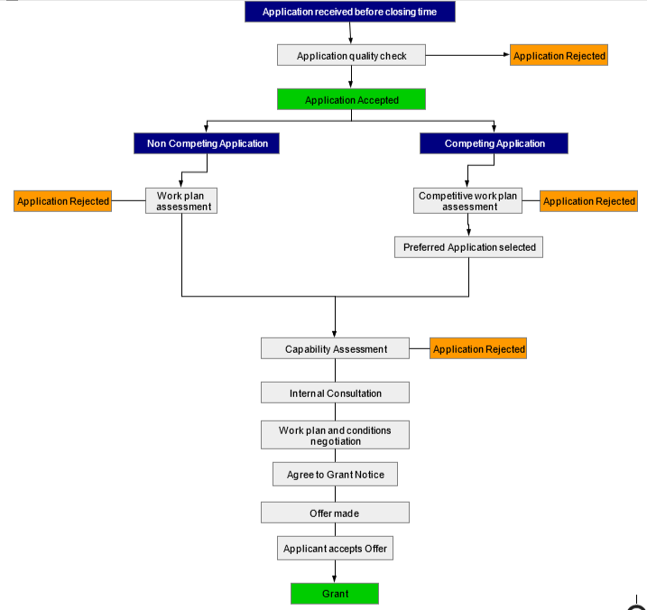

Natural Heritage, Gerald McCormack, Director, scientist and authority on Cook Islands Biodiversity (30 Jan)
Gerald McCormack is an authority on Cook Islands flora and fauna. He has developed the Cook Islands Natural Heritage website which contains all the different species of plants and animals that are found in the Cook Islands. He is currently working with a colleague on the updated version which includes Ethnobiological data on each entry. It is planned that this new version of the website will be launched during 2018.
McCormack has carried an inordinate number of research activities on traditional knowledge over the years. He has come across many instances where he has recorded traditional knowledge that the contributors have trusted him with as being “secret” and which must only be shared with members of the same family. Yet there are others who are more open about their sharing of their knowledge for the good of everyone.
Such a person was Mori Rua who in collaboration with Tom Tixier, wrote a book entitled Vai Rakau Tupuna (1985) in which he recorded several recipes for medicines using different plants which were known to be effective for treating different types of ailments. The ailments, the medicine and its ingredients, and how the medicine was prepared is all outlined in detail, in the book. Rua also assigned people to different areas of their respective islands according to the types of ailments they might normally experience. He explained that this identified where they had traditionally originated from. He claimed all rights to the knowledge but was willing to share it and make it available to all.
McCormack does not believe that a national traditional knowledge register is supported by those in the Pa Enua. Teariki Rongo, over the years worked on developing local “registers” so that the Pa Enua could record and preserve the own traditional knowledge of their respective islands. However, it is not known if these local registers actually exist. There appears to be a certain distrust among those in the Pa Enua of what might happen to their traditional knowledge once it is taken over by the more “commercially-oriented” Rarotongans. At the same time, those who are true believers in the power of the traditional medicines, are also of the belief, that even if the medicine was attempted by others, it would not work as well as it should, as its efficacy as a medicinal remedy required the mana that was associated with that knowledge. This mana was ascribed only to certain families on each island.
McCormack states that there are no endemic plants of the Cook Islands that have any medicinal properties according to traditional knowledge. All the plants that scientists are interested in, are plants that have been introduced to the Cook Islands and can be found just about anywhere else in the Pacific. There has not yet been discovered, any plant that is specifically unique. McCormack did mention that there is a limpet in Manihiki, which when “prepared” in a particular way is used as a medical remedy. I am unsure if this animal (and its traditional use) are unique to the Cook Islands
However, McCormack believes that any local plant used for particular remedies should be recorded, even as a means of, or a reason for, conserving the plant. When he has researched various plants for his database, he has also formally recorded their traditional uses and he recommends that a standardised approach is important to ensure that information about the plants is recorded accurately and that the name of the contributor of the information is also recorded. McCormack has gathered a lot of information that would be considered secret by the families concerned, but he also has their trust that their information is safe and will not be used without their permission.
From the perspective of a database development process, I was able to discuss the potential of perhaps enabling families to record the data about a particular plant, but that this would require passworded access so that no one else could access that information. This password would only be known by the contributor, and whomever he/she gave the password to. If there is privately stored information in the database, the only public information that would be required to be shown are the contributor’s name, the plant and its purpose as “Vai rakau” (traditional medicine). The recipe etc could be recorded but in a passworded file. A discussion about the database, its use and development, will take place with the Ministry of Cultural Development next week. Trust in the system will be integral to obtaining permission from the knowledge holders to have their information registered.
However, despite its lack of value as a site for research of endemic species, he sees the area of general research as a golden opportunity for the Cook Islands. As stated in the OPM report, McCormack believes that the Cook Islands should harness the interest of researchers in the Cook Islands. The Cook Islands Research Committee could promote the Cook Islands as a research destination, and encourage researchers to come to the Cook Islands, not only for studies of our environment and biodiversity, but in the area of sustainable development where researchers could offer data, for example, based on research related to the achievement of our National Sustainable Development Goals. He suggests that the Research Committee could each year propose objective areas of our NSDP that might interest researchers. The data collected would be a shared benefit of this research and information gathering opportunity for the purposes of both the Government and the researchers.

There might have to be some support given by the government if this was to be a research destination and McCormack recommends that perhaps a local “supervisor” could be assigned who could support the collection of data that would be relevant to the researcher’s goals as well as being compatible with those of the government. All benefits related to what was required by both parties could be included into the “mutually agreed terms” proposed at as an agreement within the application process. The Secretariat of the Research Unit could coordinate these liaison activities.

Te Koutu Nui, Paul Allsworth (5 Feb)

Allsworth explained the process by which Te Koutu Nui became involved with CIMTech. Permission to engage with their project was due to the involvement of a Cook Islander in the research team. The Koutu Nui met the Australian and US teams and were proud to be involved in something that might put the Cook Islands on the map. The owner of the traditional knowledge was Mrs Rongokea who used the plant to help her son and his broken leg. Supported by the Koutu Nui, she was willing to share this knowledge with CIMTech. Under the Nagoya Protocol, and because it would be the right thing to do, the Koutu Nui, would like to acknowledge Mrs Rongokea as the owner of this knowledge and will negotiate with her for some of the benefits that are currently being given to the Koutu Nui to support their RAUI projects and some operational funding. This is the only funding that the Koutu Nui gets as the government only funds their annual conference.

In a discussion relating to registering traditional knowledge, Allsworth said that because the information may be a secret within the family, there may be reluctance to register information that could be made public. I explained that passworded access could be set up so that not even Ministry staff could access the information. He felt reassured by this, but has invited me to talk to the Koutu Nui Exec tomorrow at 12 noon, to explain ABS policy development. I have told him that I would like to ask for any lessons learned from their experience and what they have learned about genetic resources.

(6 Feb) The meeting with the Koutu Nui was attended by 4 members today, as others were either off the island or missed the date. I was very grateful to be given some time in their busy meeting schedule to discuss this issue with them. It was probably timely too, that they were given some further background to the project, because I understand that they will be having a meeting with NES and CIMTech in a few weeks’ time. However, I explained that the CIMTech arrangement was very close to Nagoya Protocol expectations, without the benefit of a national policy to follow. I understand that access was given for the research project because a Cook Islander was involved. In return the companies involved have provided support for Te Koutu Nui as arranged with them, as part of their benefit sharing agreement.

However, I did remind them that it would be helpful to the development of our policy, if in hindsight if there were any other considerations that they would have done differently, probably knowing now what they know about the Protocol, then the policy team would very much appreciate hearing them. I explained the importance of the involvement of the Koutu Nui at key levels of the application process so that they could be assured that matters of importance to them – the conservation of our biodiversity and the retention of our traditional knowledge - were upheld. I also explained the process that is outlined in the Protocol with particular reference to the essential elements - Prior Informed Consent and Mutually Agreed Terms.

There was only quiet comment about some people not wanting to register their traditional knowledge, and the question was raised about the purpose of the register and why people should register. I gave reasons from the point of view of retaining our cultural knowledge and TK being part of our heritage. I explained that Gerald McCormack encouraged traditional knowledge to be recorded, but only if in some way this record could be kept private because for some it was considered a “trade secret”, but he respected that people may not trust the system enough to want to enter the information into a register.

There were no questions at the conclusion of my brief presentation, and I left a one-page summary about the Protocol and its implications for the Cook Islands. I could tell that they were all in their own way reviewing what had been said for future discussions among themselves. Paul Allsworth who is the leader of the group, indicated that they will be calling vaka meetings very shortly, and that ABS will be on their agenda. He will inform me when these meetings are to be held. I have asked Paul to provide me with any feedback from the group about ABS so that it can be considered in the policy as it is developed.

Ministry of Health, Valentino Wichman, Acting Director Community Health Services (8 Feb)

The Ministry of Health encourages research in the Cook Islands that provides benefits for the well-being of the country and its people. It has a policy and procedures that insist that any research that contains a health component requires initial approval from the MOH Research Committee before being passed on to the National Research Committee for their final approval.

While they welcome research from prospective researchers wishing to carry out health research in the Cook Islands their policy expects that research complies with basic principles and a research framework that will support successful outcomes that will meet Cook Islands Health priority goals and needs.

The Ministry of Health Research Committee initially screens all research proposals to ensure that they match topic areas related to government related (or NSDP) priorities and are appropriately aligned with the current MOH Health strategy. Once acknowledged, the application is forwarded to the National Research Committee for their further consideration. At this stage, it is assumed that it is during the NRC processes, that other factors such as the ABS Policy will be implemented. Once the research application has been accepted, the Ministry of Health has a monitoring and evaluation framework to monitor progress of the research to assist with the project’s meeting its goals for both the researcher and the Ministry.

According to Valentino, there has only been one instance in health research when plants were researched for their medicinal properties. The researcher’s findings were presented at the last Cook Islands Health Conference. This research was funded by an off-shore organization and was undertaken at the Rarotonga Hospital. The researcher is still on the island and communication has been established to get some more information from him about his work.

There was some discussion about benefits of being able to access data that has been collected by researchers. The Ministry relies on data to inform its policy decisions and researchers are often reluctant to release data they have collected in the course of their research, although if an agreement were to be made between the parties at the outset of the study, then there could be some negotiation about the sharing of this benefit between the partners. One of the suggestions was that once a research topic based on a health priority has been identified, one of the conditions that could be negotiated under the mutually agreed terms, in exchange for access to information that might not normally be made available, a local research assistant is assigned to assist the researcher to gather the data on which they will do their own analysis on behalf of the Ministry based on Ministry goals and objectives. Thus the integrity of the researcher’s own material would remain intact for their own purposes, and would be made available for the Cook Islands when the report is presented to the National Research Committee at the conclusion of the study.

Ministry of Cultural Development, Anthony Turua & Repeta Puna (8 Feb)

I found our conversation a little confusing when Repeta insisted that it was not the responsibility of the Ministry of Culture to develop a register and to seek records of traditional knowledge. They are aware that some may consider their knowledge secret but as for the compiling of a register for original musical compositions, the register for that will consist of the composer’s name and the name of the composition plus a brief statement about it. The traditional knowledge register will consist of the contributor /owner of the traditional knowledge, and a statement about the knowledge. If the knowledge is in connection with a plant then this may be incorporated into the statement, but the Ministry of Culture register will not record the plant separately, they see this role as being with biodiversity. Perhaps the medicinal qualities of a plant according to traditional knowledge could be recorded in the McCormacks natural heritage database along with the islands on which this traditional knowledge may be used for a particular plant.

It was discussed that one of the reasons that a database has not been developed yet is to do with lack of funds, however, the TK Act does state that the register could be a written record, which could be locked away and presented on request. If records kept are only of the owners and a statement about the traditional knowledge, then the owner only needs to reveal what they want, and even in their own hand.

There was a discussion about the Are Korero on each island who decides among themselves who owns traditional knowledge from their island. The Act asks for a Traditional Knowledge Advisory Committee to be set up to include one member of each Are Korero who will advise the Minister and Cabinet on the operation of the Ministry in achieving traditionally based outcomes under the Act. This Advisory Committee has not yet been established.

The Secretary mentioned that the Koutu Nui had embarrassed the House of Ariki over the CIMTech deal which should have been directed to the Ariki rather than the Koutu Nui. I am unsure as to how that situation came about, but it was acknowledged by the Secretary that the House of Ariki is funded, whereas the Koutu Nui is not. However, under the CIMTech deal the Koutu Nui are now able to operate and fund their own projects that was not possible for them to do before. I unsuccessfully tried to locate Puna Rakanui (21392) - the secretary to the House of Ariki – in order to get some further information. There is neither a representative of the House of Ariki nor the Koutu Nui on the National Research Committee. Neither group is mentioned in the Traditional Knowledge Act, so that a representative of the Are Korero, may be the most appropriate agency to be represented on the Research Committee as they are the acknowledged keepers of traditional knowledge.

A later discussion with a Koutu Nui member who was around at the time when Te Tika who was the head of the Koutu Nui, first sought their support of the CIMTECH project. Te Tika was always open and transparent about any decision making involving the traditional leaders. She had been approached by the Mathesons and after discussing the pros and cons of the arrangement with them, she then presented the proposal to the Koutu Nui., for their full discussion. If there had been any dissent from anyone, Te Tika would not have gone through with the partnership. Also, all decisions about the arrangement were made openly so that everyone knew what was going on and there were no secrets being kept from the House of Ariki. But there was no response from them at the time, so that the Koutu Nui and CIMTECH continued with their arrangements.

Access to Genetic Resources and Benefit Sharing in the Cook Islands
COMMUNITY CONSULTATIONS – AITUTAKI
Maureen Hilyard & Mathilda Miria-Tairea, Cook Islands
December 2017

Constraints:
The decision relating to the trip to Aitutaki to begin community consultations left only a limited timeframe for our consultancy team to be as well prepared as we would have liked. However, it was timely to at least have one outer island under our belt and to be able to prepare for consultations in other outer islands. After the Xmas break, Rarotonga will also have to be a priority, with visits to the Ministries and other connected agencies. However, this first outer island visit gave us some insight into islanders’ concerns and expectations about this new topic and how these can be met in our resultant document.
The time spent with the Island Government was also limited as this meeting was organised at their end of year, and was their first introduction to ABS, so that key concepts such as ACCESS, GENETIC RESOURCES AND BENEFIT-SHARING required considerable explanation in Maori in order for them to understand what the Nagoya Protocol was about. The videos on the Nagoya Protocol and ABS were also helpful for potential providers to get some understanding of what is happening in the world of ABS and how a policy such as is being established will affect and ultimately benefit them. However, this preparatory information took up valuable time that we needed in order to adequately meet our own information needs. Being introduced to it earlier, would have given them a chance to internalise it and given them time to discuss and construct questions that could have better clarified the whole process for them and helped us to provide them with an appropriate process that matched their own processes.
The same situation eventuated with the Vainetini which was gathered at short notice, many thanks to Koi Bishop (wife of the Mayor, so that many of them were just as mystified about the requirements of the Protocol, and really, how it might impact them. A second visit will be required, and by then hopefully we will have a clearer picture of the document, and will incorporate some of the issues which will have been raised during our brief consultations.
Fortunately for Aitutaki, Mathilda who is resident there, will be able to go over any issues of concern with them so that they are more aware and will be able to more fully understand the implications of the key components of the policy document. Having had an explanation in Maori, other conversations can be carried out in English, as 90% of them are more than adequate English speakers anyway.
Nevertheless, it will be important that the policy is written in both English and Cook Islands Maori in order for all local stakeholders to truly understand their rights under the protocol and subsequently under this policy. Another draft accompanies this report, based on the feedback received.
Key issues that were raised by the Island Government, and again by the Vainetini, were:
- Who are the owners of the plants, if they come from my garden? It was explained that common plants that have special local uses but on a general basis by the wider public would thus be seen to belong to all. However, if there is a particular family remedy which is widely known to stand apart from what is common usage and was used for a specific purpose because of what they knew, then it would be important for that family to register the ingredients of this remedy with the Ministry of Culture’s Traditional Knowledge Register and database. This would not necessarily require quantities which could hold the secret of the formula produced, but registering would protect the family’s interest in the particular properties of the plant which others acknowledge as having a traditional use for a particular purpose or remedy.
- How many of the plants do they need to take for their research? Emily showed a video which explained how a plant was studied in a laboratory, and that it was only a small quantity that was required for scientists to extract what they needed for their further research. From this, Liz then explained what “genetic resources” were in terms of a pen, with the ink being the “rito” which could be translated as “the centre” or the “essence” of the plant. I referred to it as the “DNA” but I am not sure that they completely understood this, as the concept is a very complex and
- By registering the knowledge that plant is used for is that like taking a patent or a copyright on the plant? It was explained that it would be difficult to take a patent out on a plant, but that the scientists could take a patent out on what they might have found in the plant. This is not the same as copyright which is the term used by the Ministry of Culture where they take copyrights out on original works of art, song and literature - intellectual property. If they decide to give a recipe, copyright may be taken out on that as intellectual property, but as it is a biological specimen that would be used, a patent would be a different type of protection for the scientists for a certain length of time. Any patents would also have to include ownership of the resource by the providers. It would have to be noted in their agreement that any patent should not hinder the provider’s use of that plant or resource for their own traditional purposes.
- It was suggested that the local traditional knowledge holders should meet to discuss the implications of what had been talked about at this meeting. It would be a good idea if Mathilda helped them with any queries that they might have. These could be reported back to me so that I can develop language which can clarify any potential misunderstandings within the document for non-fluent English speakers.

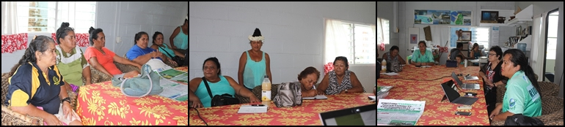

Maureen Hilyard
(13 Dec 2017)

Access to Genetic Resources and Benefit Sharing in the Cook Islands
COMMUNITY CONSULTATIONS – Mangaia
Maureen Hilyard, Cook Islands
14-16 February 2018

Although Emily had sent a draft schedule of visits so that we could cover all the bases we had hoped, the island Admin altered it due to a number of already scheduled community meetings. In hindsight, had we known of this, we would have requested a small amount of time (as we did for one community meeting through the intervention of one of our interviewees) in order to explain our purpose and to get their feedback.
By the time I had arrived, Emily had held a couple of small awareness-raising meetings in Oneroa and Tamarua villages. Attendance was low despite local TV advertisements about the meetings before her arrival. This left one more village to talk to, but we found that it too was at the same time as a village community meeting. Even so, the Mayor and two Aronga Mana members who had also attended earlier meetings, expressed their disappointment that only three other community members turned up.
While I was waiting for the plane to depart from Rarotonga airport for the Mangaia visit on Wednesday morning, I was approached by the Member of Parliament for Tamarua, Tangi Matapo, who had heard that I was visiting the island and called into the airport to talk to me about it. Her husband had told her about the local TV promotion on Mangaia. I happened to be making some adjustments to my powerpoint presentation and was therefore able to go through it with her, explaining what we hoped to achieve while we were on the island. She was very supportive and wished us well, but it was very opportune to get buy-in to the project from one of the local MPs.
Our first meeting was not until the evening, and until this time, I had a catch-up on some of my previous activities on the island, and then Taoi Nooroa, Community and Tourism Advisor, took us to some historic sites around the island. They all looked over ancient punas from lookouts perched on high cliffs. The makatea terrain denotes its age as an island. As one of the oldest islands in the Pacific, it is believed that some plants that may have been used as medicinal remedies in the “olden days” may still exist today.
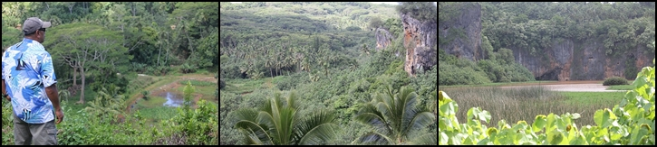
Lake Tiriara whose water flows to the sea via a subterranean channel. The Lake sits beside the puna of Veitatei and waters its gardens of banana and taro.
Maumaukura Lookout which looks over the lands of Tamarua which millions of years ago were at the same level as the brown stain on the rocks around it.
Te Pa’ata Lookout over the traditional taro plantations of the Keia puna, around which the villagers lived in the olden days

The evening meeting in Ivirua was attended by the Mayor and two representatives of the Aronga Mana, and three representatives from the community who came to our meeting before the community meeting had ended. I explained the project and the Nagoya Protocol as an introduction to why I was accompanying Emily as part of the ABS team. Among the questions that were asked at that meeting were those related to the register, and who would be listed as the owner of the traditional knowledge. The concern lay around the fact that someone could have come to the island with information and knowledge that they got from another island or from overseas. Did they own it? My suggestion was that if they were the only one on the islands with that knowledge then they did own it – on the island.
This raised the Are Korero as the keepers and managers of the traditional knowledge on the island. Mangaia has not organised an Are Korero yet. They suggested that as well as the traditional knowledge holders, that the Aronga Mana should also be part of the Are Korero. I didn’t find out until later from a community representative that the Aronga Mana is a large hierarchical group of several layers. Because Mangaia does not have a Land Court (like Rarotonga), the Aronga Mana manage their land and cultural issues. However, to include all its members might be a little over the top. However, I have suggested to the Mayor and the Aronga Mana members who were at the Ivirua meeting, that the traditional knowledge holders and the Mangaian community must themselves decide on how its Are Korero is designed, and who its members will be – in order to decide on any traditional knowledge issues. I also explained the Traditional Knowledge Act which requires a member from each Are Korero to represent them as the guardians of the Ministry of Culture.
Another comment that was raised was the arrival of a group of people from the National Environment Service several years ago asking almost the same questions about preserving traditional knowledge and establishing a register of holders of the knowledge. Emily explained that his was an earlier attempt to establish a register of traditional knowledge on each of the islands. However, from the island’s perspective they gave a lot of information, and then didn’t hear anything more after it. They suggested that this could be a reason for the poor attendance at our meetings. However, the explanation that from these meeting a national policy would be created and legislation to support the policy, helped the leaders among them to want to support it in their upcoming meetings.
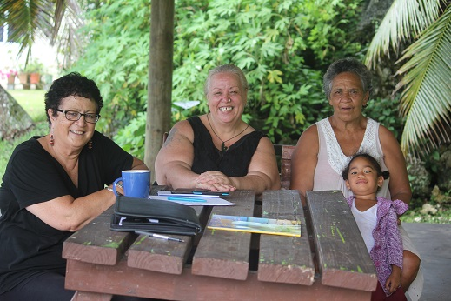
Debbie Ave, a former Ministry of Internal Affairs colleague, attempted to make contact for us with two very eminent ta’unga vai rakau on Mangaia – Ina Papatua and Teremoana Tangianau. Unfortunately, only Teremoana was available, and came to talk with us about her work on the Island. She explained that most of her medicines are told to her by God, so that she is not willing to share what has been given to her as a special gift. She was also not agreeable to having the Aronga Mana in the Are Korero. However, she was amenable to the suggestion that it was up to the island’s community to decide on its composition and how it would manage traditional knowledge about the use of plants as medicines. Teremoana was quite keen for others to hear what we were doing, and invited us to attend the community meeting that her village was holding that evening. We didn’t realise that she hadn’t actually asked the Chairman until we turned up, rather unexpectedly.
While Emily was busily unpacking the gear, I explained to the Chairman what I was there to do, focusing on the development of a national policy that would protect our biodiversity (at this stage I didn’t bother with “genetic resources”) but also our traditional knowledge based around our vai rakau. This policy would make sure that people who had the knowledge would be protected from those who might want to take it and use it for their own purposes. During this explanation, Teremoana arrived and explained our presence at her invitation having spoken to us earlier about this important issue.
The chairman mentioned that a papa’a man and some Cook Islanders had also come to them to ask about their traditional knowledge about medicines. He knew Gerald McCormack but it wasn’t him. And he also remembered Teariki Rongo coming to talk to them as well. He wanted to know if anything was going to become of this current project because they never heard from the others again. When I explained the purpose of the policy and its associated laws that would support the protection that this policy would give our ta’unga vai rakau, then he was willing to give us some of his meeting time to explain it to his community. So, Emily started by explaining the framework which has been written in Cook Islands Maori for our Cook Islands communities. The questions raised matched those from other meetings, but it made for a satisfactory ending to our community consultations.
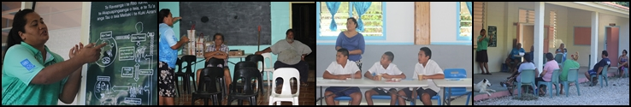
Emily explaining the Nagoya Protocol framework in Cook Islands Maori to the Mayor and the Aronga Mana, youth & the Tikura community.

The Traditional Knowledge Act (2013) defines Are Korero as:
- For powers and functions exercised and carried out under this Act in relation to traditional knowledge of a traditional community of an island of the Cook Islands other than Rarotonga and Tongareva, means the body of people authorized by the paramount chiefs of the island to exercise the powers and carry out the functions traditionally exercised and carried out by the Are Korero.
Unfortunately, this definition lacks clarity for the people who are holders of traditional knowledge about what it means to be a member of the Are Korero and what it does.
A question on Mangaia was asked: why would the Aronga Mana be on the Are Korero if they have no traditional skills and knowledge?
There was consensus among those who were spoken to that the holders of Traditional Knowledge should be members of the Are Korero but that their influence with the Aronga Mana might not be enough to entitle them to membership. Therefore, because the ACT is not clear, how would the policy identify and entitle traditional knowledge holders to rightfully take their place on the Are Korero on the island?
On Aitutaki the view is: The Aronga Mana is comprised of Arikis, Mataiapo, Rangatira, MPs, RAC, Island Government Council. It is the body that is the protector of cultural & spiritual knowledge. Therefore the Are Korero ought to answer to the Aronga Mana…as seen in Aitutaki. (Mathilda)
On Mangaia, while the ta’unga vai rakau felt that the Are Korero should recognise their skills and knowledge which she believed had nothing to do with Aronga Mana, she accepted that it was up to the community to decide on the composition of the Are Korero on Mangaia.

Accessed on 26 January 2018 from Slideshare: The International Treaty on Plant Genetic Resources for Food and Agriculture by Dr Abeer Ehalwagi, Senior Researcher – National Gene Bank of Egypt. (Nov 16, 2015).

