Maureen Hilyard

*hilyard@oyster.net.ck*

Abstract

***This report documents the travels and discussions of the ABS Team as they visited the communities of the Northern Group of the Cook Islands to explain and get feedback on the implications of the development of a national policy to implement Access to Genetic Resources and the Fair and Equitable Sharing of Benefits Arising from their Utilization (ABS or the Nagoya Protocol)***

A person standing next to a body of water

Description generated with very high confidence

A group of people posing for the camera

Description generated with very high confidence

*Everywhere*

A picture containing sky, person, outdoor

Description generated with very high confidence

*Pukapuka*

A group of people riding on the back of a truck

Description generated with high confidence

*Rakahanga*

*Tukao, Manihiki*

A group of people sitting at a table

Description generated with high confidence

*Tetautua, Penrhyn*

abs project

**Northern Group Mission 16-20 April 2018**

**REPORT: ABS Consultation visits in the Northern Group 16-20 April 2018***Nagoya Protocol on Access to Genetic Resources and the Fair and Equitable Sharing of Benefits Arising from their Utilization to the Convention on Biological Diversity (ABS or Nagoya Protocol)* **Maureen Hilyard and Mathilda Miria Tairea, April 2018**

**CONTENTS**

1. Executive summary p1
2. Introduction p3
3. ABS issues raised at the consultation meetings

3.1 Are Korero on each island p7

3.2 Some resistance among ta’unga to register their knowledge p8

3.3 Community beliefs that may deter formal registrations p8

3.4 An interview with Penrhyn ta’unga vairakau maori, Mama Takurangi Taia p9

3.5 The Traditional Knowledge Act

3.5.1 Are Korero p10

3.5.2 Requesting to make an application for registering Traditional Knowledge p10

4. Specific concerns by island communities with regards to process p11

5. Other matters

5.1 Internet connection in the Pa Enua p12

5.2 Community participation at the meetings p13

6. Conclusion p13

7. Acknowledgements p13

1. **EXECUTIVE SUMMARY**

As part of the requirement of the *Access to Genetic Resources and the Fair and Equitable Sharing of Benefits Arising from their Utilization to the Convention on Biological Diversity* (ABS), a team from the Cook Islands National Environment Service (NES) participated in a schedule of consultation visits to each of the islands in the Northern Group during the week of 16 April to 20 April 2018. The team included NES Leads – Emily Pierre, ABS Project Coordinator and Elizabeth Munro, Senior Biodiversity Officer; ABS Consultants Maureen Hilyard, policy analyst, and Mathida MiriaTairea, legal consultant; and Julie Taripo Shedden who provided media reports on the visits. The purpose of the visits was to carry out community consultation in order to gain views and opinions, as well as feedback on the draft ABS policy.

The visits to the Northern Group islands highlighted several issues that need to be addressed in order for this policy to be appropriately and properly implemented and for the policy to be effective.

First, was the need for more capacity building to enhance understanding among these communities about what they should do should they be approached by anyone seeking information about their islands. There was no one that we spoke to who knew what the formal research process involved or that there was a Research Unit. We impressed on them that it was important when anyone started making searching questions about them or their island, to ask if the enquirers had first registered their interest in their island with the Research Unit of the Office of the Prime Minister. The use of the Research Unit and its general purposes, should be prime knowledge training for Mayors and Island Executive Officers and must be clearly articulated so that they are all aware of the process and its details. A training pack should be prepared that clearly details the research and permit requirements and what the island role will be within the process expected by the Research Unit. The requirements of the Nagoya Protocol will only make up a small part of this process, but Islands leaders should at least be aware of the general process (including Prior Informed Consent and Mutually Agreed Terms) and the mechanisms (including checkpoints and a Competent National Authority) that will be in place to make it work. These mechanisms will be the responsibility of government, and whether they are in place or not will reflect on the effectiveness of the policy.

The second issue related to who had control of traditional knowledge and vairakau maori on the islands. This was the domain of the ta’unga themselves and until we raised it, there had been no consideration of coordination on any of the islands. Even the concept of the Are Korero seemed alien to them and its importance for recording all types of Traditional Knowledge. The registration requirement in the Traditional Knowledge Act goes far beyond what we were asking the local Are Korero to record. If registration of traditional knowledge associated with genetic resources is expected within the Act, then any expectations must be specific, but they must also be mindful of the cultural and social mores with respect to the ta’unga of the Pa Enua.

There is a definite need for some capacity building by the Ministry of Culture to ensure that there is at least some understanding of what the Act expects and why. At the moment, it would be difficult for anyone to appropriately comply. There seemed to have been little consultation or buy-in with the communities before the sections on the Are Korero were written into the Act. There is also no acknowledgement of local names (as in Kau Wowolo, the title given to the Aronga Mana on Pukapuka).

The third issue was in relation to registering the ta’unga and their medicine. An issue of importance to the islanders which was articulated by several meeting participants including the Prime Minister at the Manihiki meeting was “how do we protect the interests of our ta’unga and the tapu/mana of their vairakau?”. There was a lot of resistance on all the islands towards ta’unga having to register what they knew, even locally. To most ta’unga and those who were strong believers in their powers, their mana (power) and ability to heal others is a god-given gift. To give this away or to take money for its use is to diminish the mana of the owner. Ta’unga wouldn’t want to do it, and others would not expect them to because the ta’unga have strong cultural value to these communities. If a medicinal benefit from the use of a plant or animal found in the Cook Islands can help others in the world then it would reveal itself through evidence of its beneficial results. As was explained by Graham Matheson, the factual evidence from his personal knowledge and experience of the results of this traditional medicine was too startling even for a scientist to ignore and made them to want to learn more about it.

My recommendation would be to listen to the concerns of the ta’unga and their communities, and not to push too hard for ta’unga to have to register their names. Scientists are interested in facts and evidence. While we are obliged to produce a policy, it is evident that it will only be used once there is a reason to be implemented, as in the CIMTech case. Evidence that traditional medicine can produce such startling results will draw scientists and researchers to want to test the results and to find out why. Evidence will also reveal who, why and where that vairakau was used. A register may not be necessary.

The final issue was raised in our first meeting, one of the community members asked what the process would be for them to follow, in the policy. Currently the “ABS Sharing Process” within the policy (as suggested by UNDP) has been developed as a high-level document aimed at government officials and perhaps donors, etc who would understand technical-speak. It is not in user-friendly, easy to be translated, text for the ordinary Pa Enua provider.

I would recommend that a “Guidelines for ABS Users and Providers” section be included into the document before the current section on the ABS Sharing Process. It must outline the process and clearly explain what community leaders should do should anyone approach them (for the purpose of using their traditional knowledge and genetic resources). It must be in words that people can actually understand, in English and in Cook Islands Maori (the different dialects if possible). The guidelines should also include the examples of monetary and non-monetary benefits; the different mechanisms that the government will put in place in order to facilitate and support the policy; a glossary of technical terms to help people better understand the Nagoya Protocol.

1. **INTRODUCTION**

As part of the requirement of the *Access to Genetic Resources and the Fair and Equitable Sharing of Benefits Arising from their Utilization to the Convention on Biological Diversity* (also known as Access and Benefit Sharing or ABS), the Cook Islands National Environment Service organised a schedule of consultation visits to each of the islands in the Northern Group during the week of 16 April to 20 April, 2018. NES had contracted Maureen Hilyard, policy analyst, and Mathida MiriaTairea, legal consultant, to carry out community consultation in the Pa Enua in order to gain some views and opinions, as well as feedback on the draft ABS policy which had been developed in consultation with Anthony Forondo of UNDP. Media activities related to the visit and the potential for a documentary on the project-related visits were recorded by Julie Taripo-Shedden.

A group of people posing for the camera

Description generated with very high confidence

The islands that were visited included: Pukapuka, Rakahanga, Manihiki and Penryhn. The visits required major coordination work in advance, and major introduction to the project and its purpose, by the NES Leads, Emily Pierre – ABS Project Coordinator and Elizabeth Munro, NES Senior Biodiversity Officer. Their preparation for the visit included scheduling of meetings and the logistics of travel, accommodation and hosting, in conjunction with the Mayors of the respective islands. These included:

Levi Walewaoa – Mayor of Pukapuka

Neti Tarau – Mayor, and Nga Takai – Executive Officer, of Rakahanga

Ngamata Napara – Mayor, and Jane Kaina – Executive Officer, of Manihiki

Rio Teika – Mayor, and Tamu Tapaitau – Executive Officer (Acting), of Penrhyn

|  |  |  |
| --- | --- | --- |
|  | **NORTHERN GROUP MISSION – A.B.S. PROJECT - PROPOSED** | **NORTHERN GROUP MISSION – A.B.S. PROJECT - ACTUAL** |
| Mon 16/4 | AM: Depart Rarotonga 6.00; Arrive Pukapuka 8.15: Meeting #1; Stay overnight | AM: Depart Rarotonga 6.00; Arrive Aitutaki 7.30 (due to a technical fault on the Jet)  PM: Depart Aitutaki 2pm (on another aircraft); arrive Pukapuka 5pm; Meeting #1 8pm; stay overnight |
| Tue 17/4 | AM: Depart Pukapuka 7.00; Arrive Manihiki 8.00; depart for Rakahanga 9am; arrive Rakahanga 11am  PM: Meeting #2 & Stay overnight | AM: Depart Pukapuka 8.30am;  PM: Arrive Manihiki 1pm; Depart for Rakahanga 2pm; arrive Rakahanga 4.30pm; New Meeting #2 with the Island Council, 5pm; Community meeting #3, 8pm; stay overnight |
|  | AM: depart Rakahanga and arrive Manihiki;  PM: Meeting #3 (Tauhunu) & Stay overnight | AM: Depart Rakahanga 8am; arrive Manihiki 9.30am.  PM: Depart for Tauhunu @2pm to attend a funeral which all the island’s villagers were attending. Original meeting #3 was cancelled |
| Thu 19/4 | AM: Meeting #4 (Tukao);  PM: Depart Manihiki 3pm; Arrive Penrhyn 4pm & Stay overnight | AM: 9am Team accompanies villagers to a “Handing Over” Ceremony at the airport; 10.15am, New Meeting #4 (joint Tukao/Tauhunu meeting - both events attended by the Prime Minister)  PM: 2pm depart Manihiki; arrive Penrhyn 3.30; 5pm New Meeting #5; stay overnight |
| Fri 20/4 | AM: Meeting #5  PM: 4:00pm Depart Penrhyn; Arrive Rarotonga 6.20pm  End of Northern Group Mission | AM: Boat day – full community involvement – visit Tetautua for New Meeting #6 (with a ta’unga vairakau).  PM: 2pm depart Penrhyn for Rarotonga – Arrive 6.30pm |

“The best laid plans of mice and men often go awry”. This Robert Burns quote was very appropriate for our visit – but nevertheless, all meeting objectives were achieved and feedback was both positive and instructive with regards to the direction of the policy document and related legislation. But the things that were not planned included:

* A gauge fault in the Cessna Jet was identified within an hour away from Pukapuka but required us to divert to Aitutaki and await a replacement plane to continue our journey. This delayed us by about 5 hours which caused some Pukapukan locals to have to change their plans for the day. Some returned from the motu where they were camping, to attend the consultation. Despite our late arrival, we had 52 people attend the meeting in Pukapuka.

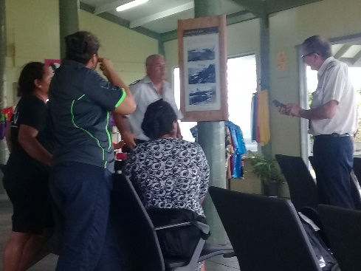 A group of people sitting on a bench

Description generated with very high confidence

*Proposing flight alternatives to Pukapuka Pukapukan community meeting participants*

* Our delayed departure the next morning because of local formalities with the Pukapukan community, coupled with a slower plane trip, meant a late arrival in Manihiki, and being met by passengers bound for Rarotonga whose original departure schedule was 1.5 hours earlier.

A group of people posing for a picture

Description generated with very high confidence A group of people standing in front of a building

Description generated with very high confidence   
*Being farewelled by the Pukapukan community Mata Hetland finally saying goodbye to Manihiki*

* We proceeded from the Manihiki airport to the wharf at 11am to meet up with the Rakahanga transporters who had left their island at 6am. The weather had become rougher by midmorning. However, the boat was very sturdy and none of the passengers considered the voyage too difficult to manage during the 2.5 hour journey.

A group of people in a pool of water

Description generated with very high confidence A person looking at the camera

Description generated with high confidence

*Departure from Manihiki Arrival on Rakahanga*

* After a traditional welcome and huge feast, the Rakahanga Council requested a preview of the presentation so that they could get a better understanding about what the workshop was going to entail. This initiative worked to our advantage as it gave the leaders some private time to ask their own questions to clarify our purpose and the requirements of the community feedback for the development of the policy. Once they understood our objectives, they became our champions during the community meeting and still had more questions to ask when they got the chance, that helped with understanding among the community as well.

A group of people standing in a room

Description generated with very high confidence A picture containing person, building, road, tennis

Description generated with very high confidence

*The Mayor and the Council at their session A section of the Rakahanga community meeting*

* After an expected attendance of the 6.30am church service, we then embarked on a much smoother and more speedy return from Rakahanga to Manihiki on Wednesday morning. On arrival on Manihiki, we were greeted with a cancellation of our Tauhunu meeting, due to a funeral to which we attended along with the Tukao community members with whom we were staying. The funeral was also attended by the Prime Minister who had arrived that morning for another event.

A group of people on a boat in the water

Description generated with very high confidence A group of people walking down the street

Description generated with very high confidence

*A lot smoother ride back to Manihiki Joining the funeral party on Tauhunu*

* It was decided that the consultation meeting the next morning (Thursday) for both villages would be held after a formal “Handing-over ceremony” which involved local landowners presenting a piece of land for the new airport terminal. Following this formality, all the participants moved to the community meeting at the Tukao Emergency Centre. The Prime Minister and his wife both participated in the discussions at this session.

A group of people posing for a photo

Description generated with very high confidence A group of people sitting at a table

Description generated with very high confidence

*Formalities at the airport with the PM Community meeting at Tukao Centre*

* The Tukao meeting went for 3 hours which meant that we had to rush to make a timely departure for our final meeting venue on Penrhyn. We had been earlier informed by the Mayor of Penrhyn who travelled with us, that due to the arrival of cargo from Rarotonga on Friday morning, the community would not be available, so we had to hold our community meeting that evening (another 3-hour meeting). It was a long day.

A group of people in a room

Description generated with very high confidence A group of people sitting posing for the camera

Description generated with very high confidence

*The Omoka meeting started at 5pm… And didn’t finish until after 8pm*

* Because of the cancelled meeting, and a return to Rarotonga planned for 2pm, the team first of all attended a local church service at 6am (with their respective religions) and then prepared to travel to Tetautua to visit and interview a ta’unga vairakau who had remained at home while others participated in the boat day activities. The day ended with a 5-hour return flight to Rarotonga.

A person standing on a rock in the water

Description generated with very high confidence A group of people sitting at a table

Description generated with high confidence *Liz checking out the marine biodiversity Emily & Mat chatting with a ta’unga vairakau*

1. **ABS ISSUES RAISED AT THE CONSULTATION MEETINGS**

There were several issues that were raised as a result of discussion about the Traditional Knowledge Act that could impact on the development of the ABS policy and its associated legislation.

* 1. **ARE KORERO ON EACH ISLAND.**
  2. The Act asks for each island to have an Are Korero to record their own register of ta’unga vairakau and other experts. The current Act does not mention ABS or what its requirements are. NES were supporting basic registry information such as (1) the name of the ta’unga, (2) what their medicine was used for, and (3) information about the different plants used in their vairakau (but the recipe was not required).
  3. Not all islands have an authority or Are Korero in place (nor are they called Are Korero)
  4. **Pukapuka** has its Kau Wowolo which is in the charge of its Aronga Mana. Any requests for research go to them first. They have had requests from researchers to do research for books, etc where the Kau Wowolo has initially imposed a $50,000 fee.
  5. On **Rakahanga**, their Council takes control of any research requests and make the decisions about what benefits they might expect from the research activity. The Council consists of the Mayor, the EO, the GR and 5 other councillors.
  6. There does not appear to be an Are Korero on **Manihiki**. Julie and I noticed a “photographic research” book on the table of our host. It contained a series of unacknowledged photos of people and places on Manihiki. While the European author cited copyright of her photos, there were no captions nor any citations of the places or of the people who were photographed. Acknowledgements are generally normal practice in any publication. As this was entitled “a research book”, it perhaps should have gone through the research unit and been registered. It is a lovely book, but it was spoiled by this lack of recognition of the locals who contributed to the publication. But locals do not realise their rights to privacy nor to acknowledgement.
  7. There is no Are Korero on **Penrhyn**, but they did ask for more explanation from the Ministry of Culture about the Are Korero and its role. They are not specified for any authority in the TK Act. They also asked for an NES officer to keep them up to date with issues such as this project. The Mayor cited an incident when the Ministry of Culture brought some people to the island to exchange cultural and vairakau information. However, after they left, nothing was ever heard again from the Ministry or the visitors about what became of the information they had given. It is for this reason that there is a lack of confidence related to giving their information to anyone, particularly the Ministry of Culture.
  8. **SOME RESISTENCE AMONG TA’UNGA TO REGISTER THEIR KNOWLEDGE:**
  9. While there was consensus that the ta’unga and their medicines on each of the islands should be protected. There were differences of opinion as to whether they should register their names and information about their vairakau.
  10. An important question was “How do we preserve our vairakau and the secrets of our ta’unga?” An important principle was “ta’unga do not accept money for their vairakau” Therefore to sell a product based on a vairakau violates the mana of the ta’unga. There were varying degrees of support for even giving it away to those outside of the family who owned the medicine.
  11. The options were a private register coordinated by the Are Korero on the island and/or the national public register based with the Ministry of Culture, and the advantages of these were discussed with the communities but there was a very protective attitude towards any form of publication of this information.
  12. It was impressed on them that both registers need only log the name of the ta’unga, the purpose for their medicine (the traditional knowledge) and the plant/s that are used for the medicine. Each ta’unga had the right to give as much or as little information as they felt was appropriate, and no “recipe” of ingredients was required.
  13. The more private on-island register, held by the Are Korero, could provide a record whereby the island community might also list the identified successor of the traditional knowledge (and the healing power). It was advised that each family should have a succession plan to pass this knowledge and the gift of healing to someone else in the family.
  14. Discussions within the Are Korero could sort out ownership issues related to any particular knowledge on the island, and to mediate any disputes about ownership or rights to the knowledge before it got out into the public domain.
  15. It was explained that the public register, held by the Ministry of Culture, would make any registered information accessible to the wider public and consequently to researchers or scientists who might be interested in the genetic resources of the listed plant or plants, based on the information given in the register plus stories they may have heard from other people.
  16. Prior Informed Consent (PIC) was emphasised and that no information could be released to anyone without the PIC of the person who was registered as an owner (a reason for being registered).
  17. **COMMUNITY BELIEFS THAT MAY DETER FORMAL REGISTRATIONS**
  18. Island communities were aware of who the ta’unga were on their island and what type of medicine their provided. During the meetings, many explained personal healing experiences and felt that this knowledge needed to be protected and retained on the island.
  19. Many had been brought up to believe that the mana of the medicine came as a God-given gift to a particular person who was charged to use this gift for making people well. If someone else tried to use this medicine it would not work because they did not possess the mana or spiritual power to produce the required results.
  20. It was suggested that once information about local medicine was given away, it lost its value and subsequently, its power. No-one else could use that medicine effectively because it was a gift given by God to the owner of the medicine.
  21. There was a concern that with scientists uncovering the genetic components of a plant that was used for healing, this would reveal the “secret” ingredient of that medicine, and thereby diminish the mana of the “gift” that belonged to the original owner.
  22. Because a ta’unga would not normally charge for their services, it would not be appropriate for them to receive any monetary benefits from a research activity that might be agreed to. The premise being that to sell their vairakau would also contribute to the loss of their mana.
  23. On the other hand, there were others who believed that their knowledge was given to them to share. Sharing within a family group was common.
  24. Often this knowledge was shared among outsiders. Yet, over time as many people shared the same knowledge, the identity of the original owner was lost. Problems could arise when someone tried to register a medicine as their own when in fact it may have been copied from someone else generations ago.
  25. It was mentioned on several occasions that there have been instances where those who did not use their knowledge appropriately, themselves became sick and could not be cured by their own medicine.
  26. **AN INTERVIEW WITH PENRHYN TA’UNGA VAIRAKAU MAORI – MAMA TAKURANGI TAIA (by Mathilda Miria-Tairea)**

A person sitting on a bed

Description generated with high confidenceABS Project Manager, Emily Pierre and I had a conversation with **Mama Takurangi** **Taia** which took place in her home on the island of Tetautua, Tongareva on Friday 20th April 2018 @11.45am.

Mama T (as I will refer to her) holds the knowledge of numerous *vairakau* for different ailments ranging from rashes, boils, migraines, after birth cleansing, healing of the womb or the cervix during delivery, to broken bones, ridding the home and property of evil spirits and even one for love.

Mama T is mentoring and passing on her traditional knowledge gained from her parents and grandparents handed down over the years to her grandson Small Taia who together with his brother both care for mama.  He now prepares the medicine, given mama is no longer able to mobilize herself and she instructs him. In this manner the traditional knowledge associated with genetic resources will not be lost when Mama transitions.  She is 84 years of age and requires help for most basic things.

 Mama T is against the development of legislation, and believes that *vairakau*, should not be shared, given it is prepared with prayer and captures the essence and spiritually of the medicine during the preparation of the *vairakau* - sacredness and sanctity play a great role particularly, when it is done for the person who needs it. Therefore, there is no monetary value or price for the medicine. There are protocols when she prepares the medicine and it is not a task that is taken lightly.

She believes that *vairakau* should always remain sacred, it should not be shared as the power of the medicine lies in the manner in which it is prepared, there are procedures for its preparation, whomever has been given the knowledge, passed down through the family, is the guardian of that medicine/s.

One of the grandsons Teako Taia (the pilot who was driving the boat for us today), has also been given some of the traditional knowledge, but one has to remain with the ta’unga in order to learn the practices involved in the preparation of the vairakau and applying them for the greater good of the community.  Mahuta Akataputi is the 3rd grandson who was the other pilot on the boat.  I take my hat off to Small Taia who has given up his life to care for his grandmother and to pick up the baton down the track and become the family’s next ta’unga.

* 1. **THE TRADITIONAL KNOWLEDGE ACT**

**3.5.1 Are Korero**

1. During our island visits we found that there was little understanding at all about the Traditional Knowledge Act and Are Korero – that is, how the Ministry of Culture envisages the composition, roles and responsibilities of Are Korero.

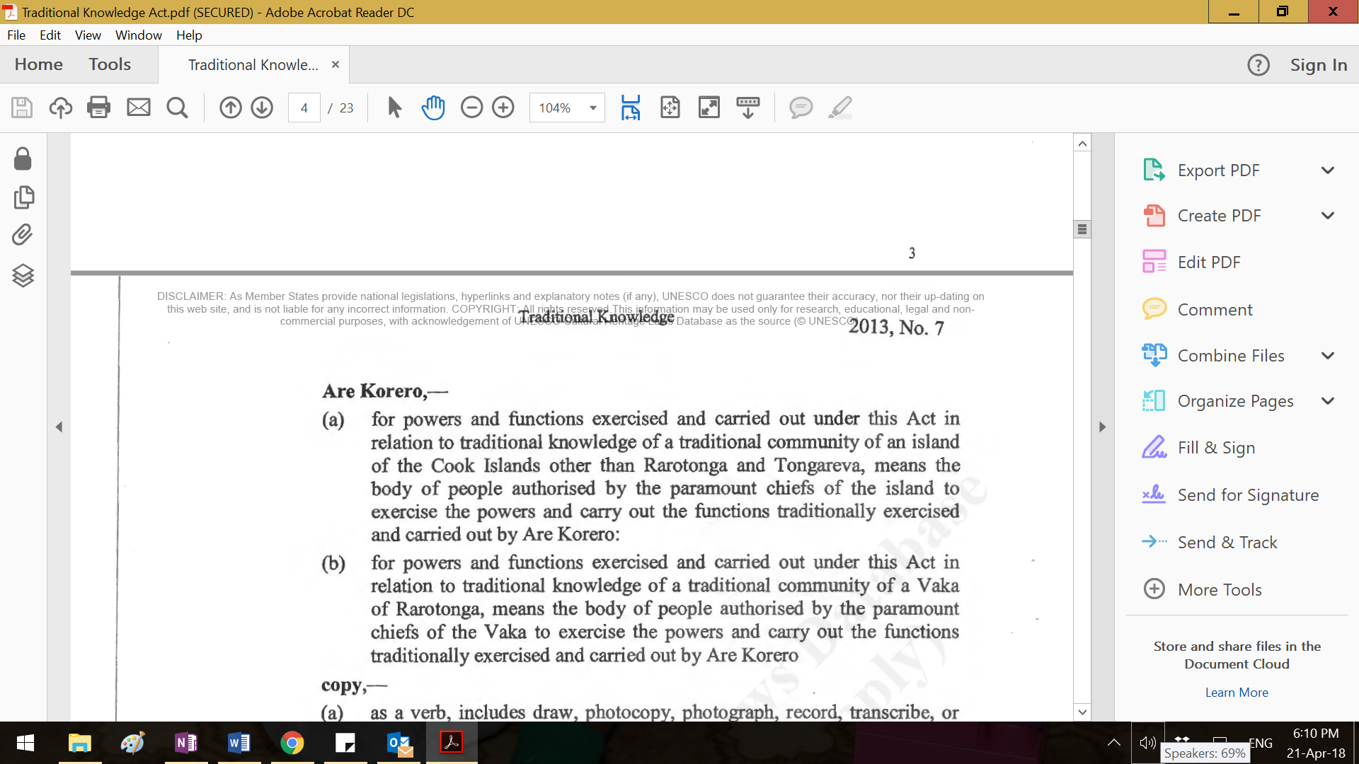

1. Tongareva community among others, requested that more details about the process with regards to how to deal with people who come to the island and ask to do some sort of research about their island or its culture.
2. Tongareva is excluded from the definition of Are Korero in the Act, and the traditional knowledge of that community is not addressed. They feel that they were poorly treated with regards to the information that was given at the request of the Ministry of Culture, with no protections in place with which to protect their traditional knowledge, yet with no return information about what happened to it from the Ministry when a request was made to the Secretary at the time.
   * 1. **Requesting to make an application for registering Traditional Knowledge.**
   1. In order to apply to register with The Traditional Knowledge Act, the Act requires the following which is “totally over the top” for many who are being asked to register their ABS related information. We were suggesting something a lot less demanding information-wise (and probably in keeping with global privacy trends). The consensus from the island feedback we got, was that any application for registration must first be agreed to by the Are Korero before it goes to the MOCD and that before any information can leave the island, permission must come from their community’s authorised leadership group.

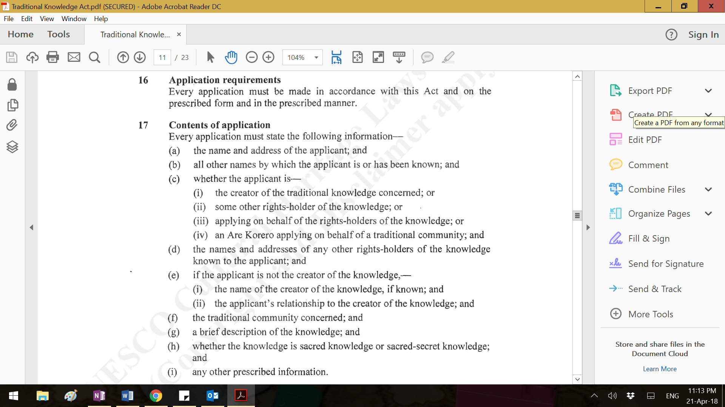

* 1. Some islands already had processes in place but would like to formalise these, according to this new policy:
  2. Pukapuka have a **Kau Wowolo** which is comprised of the Aronga Mana and the Council who make all the decisions about any requests for study about their island and its culture. These decisions include negotiating for any benefits that they might receive from the research activity. One meeting participant believed that the benefits should be monetary (although the traditional knowledge requests that they get are currently not related to vairakau). It is unknown if they also refer these requests once given to the Research Unit of the Office of the Prime Minister which is the normal process for any study done on the island.
  3. On Rakahanga, the **Council** (as they referred to themselves) is in charge of any decisions relating to the island. The Council includes the Mayor, the Executive Officer, the GR, the MP and five village representatives. If any researchers wanted to work on a cultural subject, then their negotiating would have to be done with the Council. Again, it is not known as to whether these requests are passed on to the Research Unit which is supposed to be normal practice, but it is a practice that they are not familiar with. Who informs them of this process?
  4. On Manihiki and Penrhyn, the Island Governments consisted of the Mayor, the Executive Officer, the MP and a number of village councillors. There is no evident specific or formal process. The views presented at both meetings were individual, with no formal authority to fall back on as was the case in Pukapuka and Rakahanga.

1. **SPECIFIC CONCERNS BY ISLAND COMMUNITIES WITH REGARDS TO PROCESS.**

These common questions were raised by the island communities and indicate that the policy needs to address these issues of concern to community users of the policy. The language of the policy needs to be in terms that are easily understood by non-English speakers (even if another version in Cook Islands Maori is offered – though this was not available during our visit). It also needs to be helpful in guiding them towards practical decisions relating to ensuring that they give Priori Informed Consent and that they are aware of the criteria that would give them the full benefits of the Mutually Agreed Terms. They also wanted to know what mechanisms will be in place to help them make good decisions, should an ABS opportunity ever arise for them.

4.1. Common questions and comments, that were responded to by the ABS team during the meetings:

4.1.1 When people register their vairakau, do they have to list the ingredients of their medicine? (no)

4.1.2 How would people know who was the owner of a particular medicine? (consultation within the ta’unga community and the Are Korero, on the island)

4.1.3 Who owns the medicine when the same medicine is made by lots of people on different islands? (according to the TK Act, Are Korero from the different islands decide together)

4.1.4 I doubt any ta’unga will tell you about their medicine. Their medicine is from God and the power is given to the individual

* + 1. A ta’unga cannot practice their medicine outside of their boundaries
    2. The value of the medicine to the island lies in its use by those who are authorised to apply it
    3. If you organise an agreement with a company, and they go overseas and you never hear from them again, how do you know what they are doing? (legal agreement, checkpoints, etc)
    4. While the ta’unga might only record the ingredients in the register, scientists can still find out what the secret ingredient is, and can reveal it. The mana of the medicine can be lost if we share it. (Communities were reminded that no-one will be allowed to research without the Prior Informed Consent of the owner of that knowledge)
    5. How will all our ideas be incorporated into the new policy? (with difficulty)
    6. We already have a process in place, why do we need this policy? (just in case)
  1. Some advantages indicated by registering
     1. What happens when a ta’unga dies and that knowledge is lost?
     2. How do we distinguish how we do things on our island and how they do things on other islands?
     3. (By registering) people might find a medicine on our island that they might need.

4.2.4 It would really help our country, if one of the benefits was that our children might be able to become scientists or researchers.

1. **OTHER MATTERS** 
   1. **INTERNET CONNECTION IN THE PA ENUA**

It must be mentioned that all the islands we visited had 100% renewable energy and therefore power was available 24/7. However, internet connection via Blue Sky hotspots was inconsistent. The best internet service was on Pukapuka, Rakahanga and Tetautua in Penrhyn where good wifi connectivity was available up to 50 metres of the hotspot. On Tukao, Manihiki, the only wifi hotspots were based at the emergency centre and the BlueSky station – requiring us to walk some distance from our accommodation at night to access emails and to send messages home. On Omoka (Penrhyn) we had to be almost on the satellite dish at the BlueSky station to access the internet, whereas at Tetautua, the central wifi hotspot provide good connectivity for virtually the whole islet.

* 1. **COMMUNITY PARTICIPATION AT THE MEETINGS**

|  |  |  |  |
| --- | --- | --- | --- |
| **Island** | **Population** | **Attendance** | **%** |
| Pukapuka | 400 | 52 | 13% |
| Rakahanga | 97 | 23 | 25% |
| Manihiki | 260 | 38 | 13% |
| Penrhyn | 226 | 31 | 14% |

1. **CONCLUSION**

There are four main issues with regards to the development of this policy. The recommendations made as a result of investigating these issues are:

1. That a TRAINING package be prepared by the Research Unit of the Office of the Prime Minister for the Mayors and Island Governments of the Pa Enua in order to clarify the PROCESS that is involved in anyone seeking to research any activity or person, site or traditional practice, etc. They will also require training in the use of the material that will explain the differences between ordinary research and research that is connected to the Nagoya Protocol
2. The Ministry of Culture needs to revisit its Traditional Knowledge Act and to ensure that all cultural leaders are aware of its requirements and expectations. Some Pa Enua communities already have mechanisms in place that are similar to what is assumed to be expected of the Are Korero, cited in the Traditional Knowledge Act. But each island has its own cultural practice. The Ministry of Culture must make themselves aware that in the Northern Group, none of the islands is complying as expected with the Act with regards to recording traditional knowledge, because they are unaware of what the Act is supposed to achieve.
3. Communities were very protective of their ta’unga and their vairakau and there was strong resistance by communities towards the registration process. This was consistent across the islands. Because the mana of a healer was given by God, it made the ta’unga tapu. Only that person was authorised to heal and his/her value and power would be diminished if they gave any of their secrets away or took money for its use. We must be cognisant of this cultural more so that my recommendation would be not to make formal registration of ta’unga a requirement of this policy. Scientists and other researchers will always be looking for evidence of something that is of value to them. It is this evidence which, like the CIMTech case study, can offer the Cook Islands an opportunity to explore benefits for both users and providers.
4. The policy itself, has been identified as requiring an addition that offers local users some better more user-friendly understanding of what the Nagoya Protocol and its requirements are all about. “Guidelines for ABS Users and Providers” must be included in the policy, as well as the set of possible benefits, a glossary of technical terms and the various mechanisms that the government will put in place to support the effective and efficient implementation of the ABS policy. All of these documents must be in English and Maori.
5. ***Acknowledgements:***

We were very grateful for the hospitality and generosity of the Island Governments – the Mayors and Executive Officers and their communities - of the islands we visited. We must especially thank our hosts on Pukapuka and Penrhyn for the government buildings that were made available for our use, and to our hosts on Rakahanga and Manihiki, we really appreciated being welcomed into the homes of Takai Hagai on Rakahanga and Sam and Niki Karaponga on Tukao, Manihiki. On all the islands we tasted local delicacies that we wouldn’t normally get on Rarotonga. Special thanks to Sam Karaponga for enabling us to share in the farewell to a member of the Tauhunu community. We also appreciated being able to attend an important handing-over ceremony at the Tukao airport, as well as to make an impromptu visit to Tetautua and gain the bonus of an interview with a ta’unga vairakau. For Julie and Maureen, the trip provided an opportunity to reconnect with family members. These personal contacts and important events made the whole trip extra special.

Thank you to the National Environment Service for making this trip possible, and to enable us to gather more information that will be of value to creating the ABS policy document and its associated legislation which will be useful for ABS users and providers in the future.

*Maureen Hilyard and Mathilda Miria-Tairea*

*April 2018*